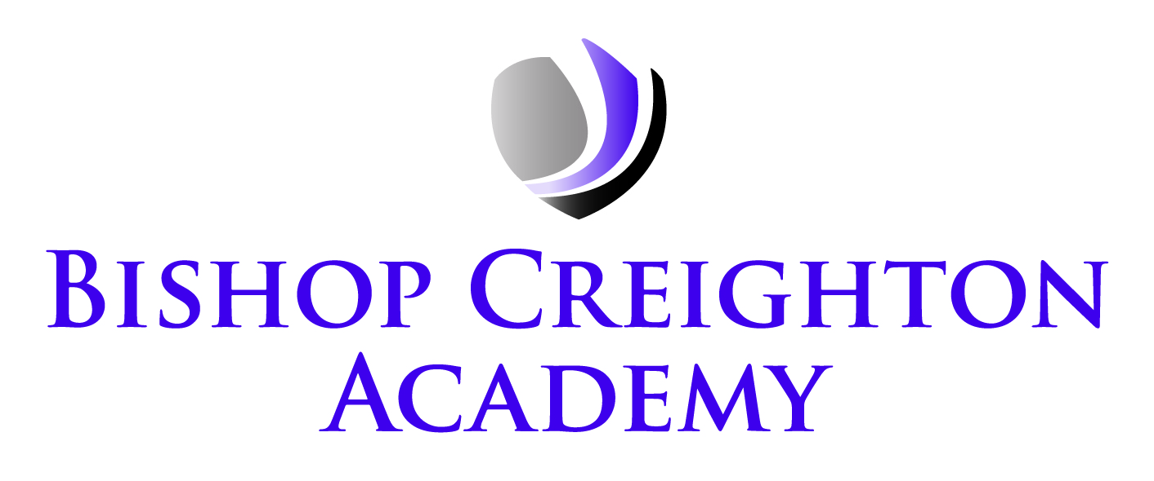
Executive Principal: Mrs V Redhead
Interim Head of Academy: Mrs K Baldock
Vineyard Road
Peterborough PE1 5DB
Telephone: 01733 343895
Email: admin@bishopcreightonacademy.org
Website: www.bishopcreightonacademy.org
Twitter: @BCA_Academy

Friday, 2 May 2025

Key Stage 2 National SATs Week – Monday 12th May to Thursday 15th May 2025

Dear Parent/Carers,

What is the timetable for the week?
The tests will run from Monday 12th May to Thursday 15th May 2025 Each day the children will have one or two tests to sit. On days where there is more than one test the children will have a break and fresh air before sitting the next test.

Monday 12th May 2024 | Spelling, Punctuation and Grammar: Paper 1- Short Answer (45 minutes)  Spelling, Punctuation and Grammar: Paper 2- Spelling Test (20 minutes)
Tuesday 13th May 2024 | Reading (60 minutes)
Wednesday 14th May 2024 | Maths Paper 1: Arithmetic (30 minutes)  Maths Paper 2: Reasoning (40 minutes)
Thursday 15th May 2024 | Maths Paper 3: Reasoning (40 minutes)

On each day of the SATs we will be running a breakfast club for Year 6 pupils to help prepare and relax the children. Cereal and toast will be on offer each morning. On Friday we will have a special breakfast, after we have finished the final test.

Can we please remind you once more of the things that you can do to help during SATs Week:

- make sure that your child gets plenty of sleep
- try to keep your child relaxed and confident
- ensure that your child is at school and on time every day

If you have any questions, please do come and ask a member of the Year 6 team.

Have a lovely weekend.

Yours sincerely,
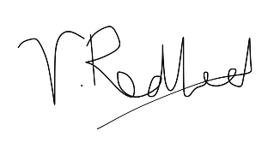
Mrs V Redhead
Executive principal

