
Executive Principal: Mrs V Redhead
Interim Head of Academy: Mrs K Baldock
Vineyard Road
Peterborough PE1 5DB
Telephone: 01733 343895
Email: admin@bishopcreightonacademy.org
Website: www.bishopcreightonacademy.org
Twitter: @BCA_Academy

28th November 2024

Swimming Year 3&4 Spring Term: Thursday 9th January -Thursday 27th March 2025

Dear Parents/Carers,

Years 3 & 4 will be swimming this term at Stanground Sport Centre. Swimming forms part of the National Curriculum and all children should take part. The class teacher must be informed in writing if there is a reason why your child is unable to attend a swimming lesson.

Swimming lessons will take place each Thursday, 10am – 11am.

The academy is paying for the cost of the swimming lessons. However, we still require a contribution of £2.50 for each session per pupil for transport. We will be travelling to the Stanground Academy by coach. This can be made weekly or as a one-off payment of £25.00 through Parent Pay.

We will be supported by an Aspire swimming instructor provided by Stanground Academy Sports Centre.

Swimming kit is as follows:

- One piece costume for girls
- Trunks for boys (not cut-off denims or beach shorts)
- Towel
- Swimming hats must be worn by every pupil
- Long hair must be tied up
- No child can enter the pool wearing jewellery

Asthma inhalers will be taken from school.

Yours sincerely,

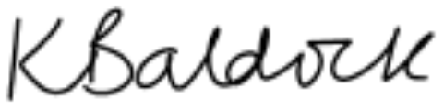

Mrs K Baldock
Interim Head of School

