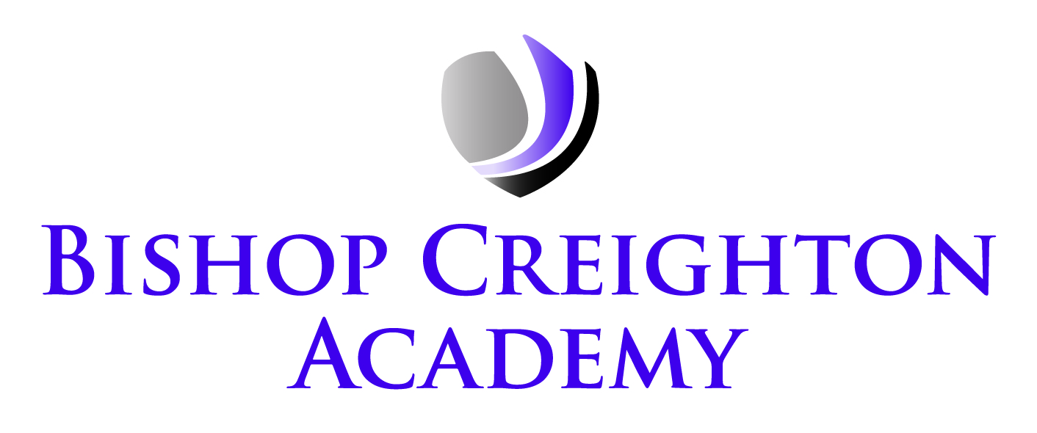
Executive Principal: Mrs V Redhead
Head of School: Miss K Snell
Vineyard Road
Peterborough PE1 5DB
Telephone: 01733 343895
Email: admin@bishopcreightonacademy.org
Website: www.bishopcreightonacademy.org
Twitter: @BCA_Academy

September 4, 2024

Year 1 Phonics Workshop – Tuesday 1st October
Dear Parent/Carer,

We would like to invite all parents and carers of Year 1 children to attend a phonics workshop, which will be held at Bishop Creighton Academy on Tuesday 1st October at 2:15pm. At Bishop Creighton, we believe that children must learn to read so that they can read to learn. Phonics is a crucial skill that helps children to do this, and we believe that your involvement is incredibly important.

During the workshop, we will provide an overview of the Year 1 Phonics Screening your child will sit in June and explain the key terminology and procedure. We will then invite your children into the session to have a phonics lesson, so you can work alongside them. The workshop will last until 3:00pm.

We kindly request that you confirm your attendance by returning the completed form to school by Monday 23rd September. This will help us with planning and organising the event effectively. Unfortunately, we are unable to provide childcare facilities during the workshop.

Thank you for your continued support, and we look forward to welcoming you to the workshop.

Yours sincerely,

Helen Evans
English Lead

Year 1 Phonics Workshop – Tuesday 1st October
Please circle as appropriate.

I confirm I would/not like to attend the phonics workshop on Tuesday 1st October at 10:00am.

Adult’s name: ____________________________________________________________________

Child’s name: ____________________________________________________________________

